Database Course Documentation Report  
*By: Loay AL-Sinani*

**1. Flat File Systems vs. Relational Databases**

Data storage systems have significantly evolved over the years. Before modern relational databases, data was often stored in flat file systems. Although both systems are used to store data, they differ significantly in structure, performance, and usability. The following is a detailed comparison based on five major criteria.

**Comparison Table**

|  |  |  |
| --- | --- | --- |
| Feature | Flat File System | Relational Database |
| Structure | Simple files (text or binary). Data is not stored in tables. | Structured format using rows and columns (tables). |
| Data Redundancy | High redundancy due to lack of central control. | Redundancy is minimized using keys and normalization. |
| Relationships | No direct relationship between different files. | Tables can be related using primary and foreign keys. |
| Example Usage | Storing user settings or configuration files. | Student management systems, inventory systems, banking apps. |
| Drawbacks | Difficult to update, manage, and scale. | Requires skilled personnel and proper design for optimal usage. |

**Additional Details**

Flat file systems are easier to create and understand for beginners. They do not require complex software or special skills, but become inefficient as data grows. Relational databases follow strict schema rules, allowing multiple users to access, update, and manage data concurrently with better security and integrity.

**Visual Representation**

You can imagine a flat file system as a collection of documents in a cabinet, each holding separate information with no link between them. In contrast, a relational database is like a spreadsheet with multiple interconnected sheets using references.

**2. DBMS Advantages**

A Database Management System (DBMS) brings several key advantages over traditional storage approaches. The mind map includes the following core benefits:

**Advantages (with Notes):**

* **Security**: Controls access with user authentication and roles. Protects sensitive data from unauthorized users.
* **Integrity**: Enforces data rules and constraints to ensure accuracy and consistency.
* **Backup**: Automated backups ensure data safety and fast recovery from crashes.
* **Redundancy**: Eliminates duplication through normalization and referencing, reducing storage costs.
* **Concurrency**: Allows multiple users to access and modify data simultaneously without conflicts.
* **Data Sharing**: Centralized data can be accessed by various users and applications for collaborative work.

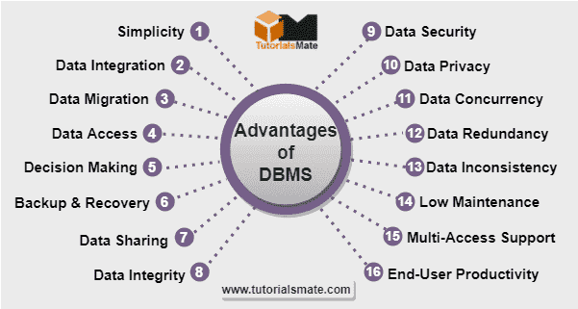

**Extended Benefits**

* **Efficiency**: Queries allow fast search and retrieval of data.
* **Scalability**: Databases can handle increased workloads and larger datasets.
* **Standardization**: SQL provides a standard language for interacting with data.

**3. Roles in a Database System**

**System Analyst**

* Works with clients to gather requirements.
* Documents needs and defines the scope of the project.
* Analyzes business processes and ensures the solution meets real-world needs.

**Database Designer**

* Responsible for planning the structure of the database.
* Designs the ERD (Entity-Relationship Diagram).
* Ensures normalization and scalability.
* Prepares the logical schema for implementation.

**Database Developer**

* Implements the design using SQL and other tools.
* Writes queries, stored procedures, and database logic.
* Works with programmers to integrate the database with applications.

**Database Administrator (DBA)**

* Maintains and secures the database.
* Performs backups, restores, and tuning.
* Monitors system health and usage.
* Manages user roles and access privileges.

**Application Developer**

* Builds applications that connect to the database.
* Uses programming languages and APIs to enable data interaction.
* Tests and debugs application-database communication.

**Business Intelligence (BI) Developer**

* Transforms raw data into meaningful insights.
* Creates reports, dashboards, and predictive models.
* Uses data mining, machine learning, and visualization tools.
* Helps management make data-driven decisions.

**4. Types of Databases**

**Relational vs. Non-Relational Databases**

* **Relational Database**
  + Uses tables to store data.
  + Suitable for structured data.
  + Supports ACID properties (Atomicity, Consistency, Isolation, Durability).
  + Examples: MySQL, PostgreSQL, Oracle.
* **Non-Relational Database**
  + Flexible structure (key-value, document, graph, etc.).
  + Ideal for unstructured or semi-structured data.
  + Scales horizontally for big data use.
  + Examples: MongoDB, Cassandra, Redis.

**Use Case Examples:**

* Relational: Student records, payroll systems, banking.
* Non-Relational: Social media feeds, log files, IoT sensor data.

**Centralized vs. Distributed vs. Cloud Databases**

* **Centralized Database**
  + Data is stored at a single location.
  + Easy to manage but vulnerable to failure.
  + Low latency within the network.
  + Use Case: Small businesses, single-site organizations.
* **Distributed Database**
  + Data is stored across multiple locations.
  + Increases reliability and availability.
  + Complex synchronization and management.
  + Use Case: Multinational companies, real-time analytics.
* **Cloud Database**
  + Hosted on cloud platforms.
  + Offers scalability, accessibility, and cost-efficiency.
  + Managed infrastructure and built-in security features.
  + Examples: Google Cloud Spanner, Amazon RDS, Azure SQL.

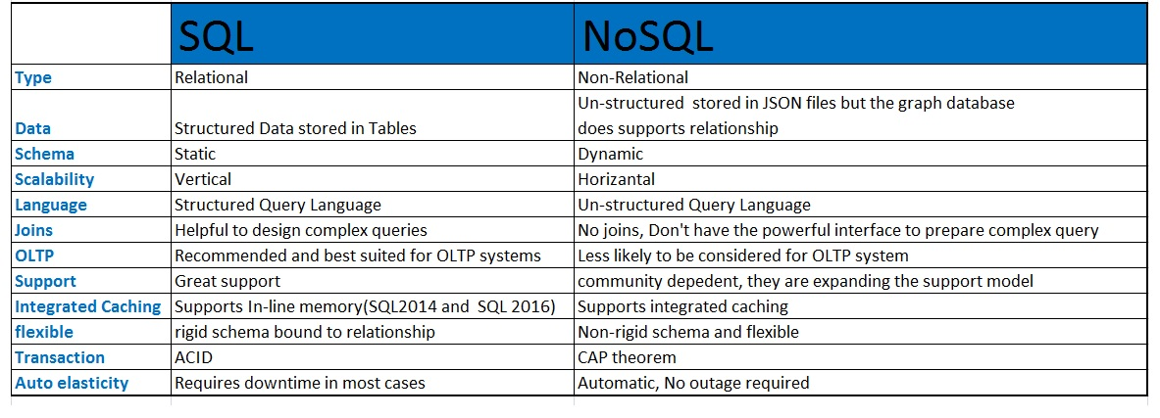

**5. Cloud Storage and Databases**

**What is Cloud Storage?**

Cloud storage allows users to save and access data online through internet-connected services. It supports database functionality by hosting databases on scalable, remote servers.

Cloud platforms also provide built-in tools for database backup, high availability, disaster recovery, and global access. This helps businesses focus on their applications without worrying about infrastructure maintenance.

**Advantages of Cloud-Based Databases**

* **Accessibility**: Can be accessed from anywhere.
* **Scalability**: Resources grow with demand.
* **Cost Efficiency**: Pay-as-you-go models.
* **Maintenance-Free**: Managed by the provider.
* **High Availability**: Uptime guarantees and geo-redundancy.
* **Security**: Advanced encryption, compliance support (e.g., GDPR, HIPAA).

**Disadvantages of Cloud-Based Databases**

* **Internet Dependency**: Requires stable connection.
* **Data Security**: Sensitive data needs strong protection.
* **Vendor Lock-In**: Moving data between platforms can be complex.
* **Compliance**: Certain industries have strict legal requirements.

**Popular Providers:**

* **Amazon RDS** – Fully managed relational DB.
* **Google Cloud Spanner** – Global-scale database with high availability.
* **Azure SQL Database** – Intelligent, scalable relational DB.
* **MongoDB Atlas** – Cloud-hosted NoSQL database.

**Conclusion**

Databases are the backbone of modern digital systems. From traditional flat file systems to sophisticated cloud-based relational databases, each advancement has addressed limitations of the past. Understanding the structure, roles, and technologies involved helps us design efficient, secure, and scalable systems.

With the growth of cloud computing, businesses now have access to highly available, cost-effective, and globally distributed database systems that adapt to their needs. Learning these concepts prepares students to work in real-world environments and contribute to data-driven decision making.

**References**

1. Introduction to Database – Class PDF
2. MongoDB Official Docs – <https://www.mongodb.com/docs/>
3. AWS RDS Overview – <https://aws.amazon.com/rds>
4. Microsoft Azure SQL Docs – <https://learn.microsoft.com/en-us/azure/azure-sql/>
5. Google Cloud Spanner – <https://cloud.google.com/spanner>
6. DBMS Tutorial – GeeksforGeeks – <https://www.geeksforgeeks.org/dbms/>
7. IBM Cloud Databases – <https://www.ibm.com/cloud/databases>
8. Oracle DBMS Concepts – [https://docs.oracle.com](https://docs.oracle.com/)
9. PostgreSQL Official Site – [https://www.postgresql.org](https://www.postgresql.org/)